Lab Exercise 3- Working with Git Rebase
Lab Exercise: Git Rebase
This exercise demonstrates the use of git rebase in a scenario where no conflicts occur.

Objective
- Learn how to rebase branches when there are no conflicting changes.
- Understand the clean, linear history created by git rebase.

Prerequisites
- Install Git on your system.
- Initialize a Git repository:
git init git-rebase-lab
cd git-rebase-lab
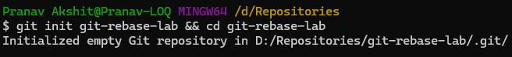

Step-by-Step Instructions
1. Set Up the Repository
- Create the main branch and make the initial commit:
echo "Line 1 from main branch" > file.txt
git add file.txt
git commit -m "Initial commit: Add Line 1 from main branch"
- Create a new branch feature-branch:
git checkout -b feature-branch
- Add a new line to file.txt in feature-branch:
echo "Line 2 from feature branch" >> file.txt
git add file.txt
git commit -m "Add Line 2 from feature branch"
- Switch back to the main branch and add another line:
git checkout main
echo "Line 3 from main branch" >> file.txt
git add file.txt
git commit -m "Add Line 3 from main branch"

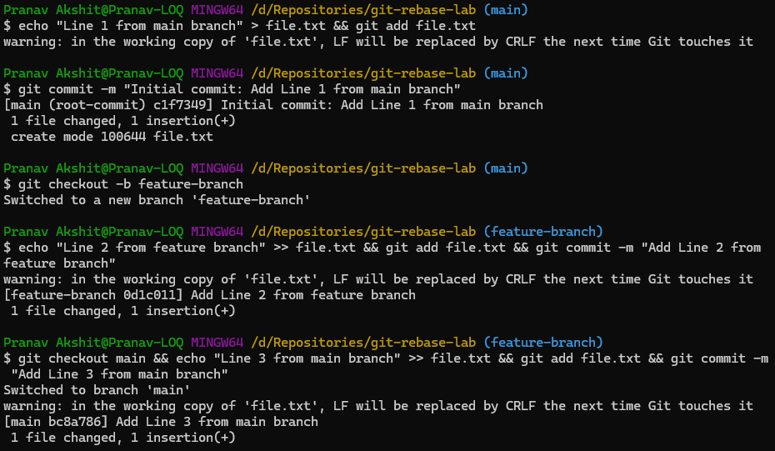

2. Rebase feature-branch onto main
- Switch to feature-branch:
git checkout feature-branch
- Rebase feature-branch onto main:
git rebase main
- Git will replay the commit from feature-branch onto the main branch. Since there are no conflicts, the rebase completes automatically.



3. Verify the Rebase
- View the commit history:
git log --oneline
git log --oneline --graph
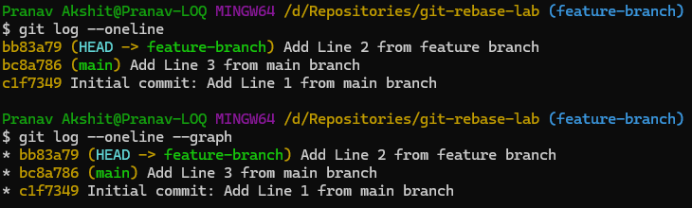
- Check the contents of file.txt:
cat file.txt
Output:
